MD2201 Data Science
Home Assignment
AY:2021-22 SEM II
S.NoDivBatch NoGroup NoRoll NoGr.NoName of Student1D338012120172PATIL MANASI 28912120061SONAWANE HARSHAL 37912120057PATIL CHAITANYA 48112120128PATIL SHASHANK 59112120087THAKUR UMA 67812120056PATIL BHAVIN Science

Date of performance:

Data Visualization:

Statement: Use minimum two different appropriate visualization tools for visualizing/comparing the data

Code:

Bar Plot: ggplot(train, aes(fill=ReferenceArea, y=Scale, x=TimePeriod))+geom_bar(position="dodge", stat="identity")+theme(axis.text.x =element_text(angle=90,vjust=0.5),plot.title=element_text(color="black",size=16,face="italic"))+labs(x="",y="Value",title="Primary Expenditure of 5 Countries")
Box Plot: ggplot(train,aes(ReferenceArea, Scale,fill=ReferenceArea))+geom_boxplot(outlier.color="red",outlier.shape=4,outlier.size = 4)+theme(legend.position = "dodge")+ggtitle("Boxplot")+xlab("Reference Area")+ylab("Scale Values")

Plot:

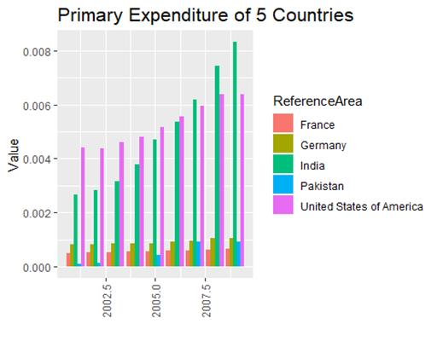

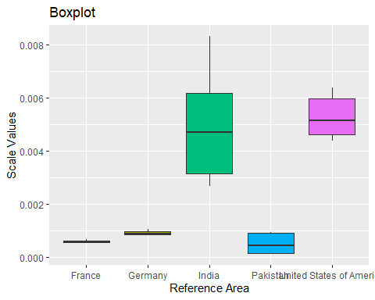

Conclusion:

Bar Plot: Plotted a Bar Plot for Primary Expenditure of 5 Countries. Showing Scaler values in Y axis and Time period on X axis. Using ggplot function along with aesthetics function to specify graphing elements.

Box Plot: For Box plot, the same function is used with geom_boxplot function instead of geom_bar function. On X axis the Reference area name are given and on Y axis it is showing the scaler values.

2. Details of Meta Data:

Name of Data Set | Link
Gross domestic expenditure on R & D | https://data.un.org/

str(train)
## 'data.frame': 41 obs. of 4 variables:
## $ ReferenceArea : chr "India" "India" "India" "India" ...
## $ TimePeriod : int 2001 2002 2003 2004 2005 2006 2007 2008 2009 2001 ...
## $ ObservationValue: num 1.70e+11 1.81e+11 2.01e+11 2.41e+11 2.99e+11 ...
## $ Scale : num 0.00267 0.00284 0.00315 0.00378 0.0047 ...
summary(train)
## ReferenceArea TimePeriod ObservationValue Scale
## Length:41 Min. :2001 Min. :7.018e+09 Min. :0.0001101
## Class :character 1st Qu.:2003 1st Qu.:4.107e+10 1st Qu.:0.0006443
## Mode :character Median :2005 Median :6.148e+10 Median :0.0009647
## Mean :2005 Mean :1.681e+11 Mean :0.0026370
## 3rd Qu.:2007 3rd Qu.:2.993e+11 3rd Qu.:0.0046965
## Max. :2009 Max. :5.304e+11 Max. :0.0083223

Reference Area | Class: Character  Mode : Character  Length : 41 | contains the name of different countries.
Time Period | Class: Integer  Mode: Numeric | Year in which government, consumer and business investment has spent.
Observation Value | Class: Numeric  Mode: Numeric | Sum of all final goods and services in economic in that particular year.
Scale | Class: Numeric  Mode: Numeric | Normalized value for observation values.

Data Preprocessing:

Details of Techniques used for Data cleaning

First, we have separated the columns with same objects from the given dataset we have removed the Sex, Age.group and Units.of.measurement columns. Using the combine function created a df dataset which only contains operational columns. From caret package preProcessing function is used to convert the observation values into scaler values. Lastly, we have taken the 5 primary countries as our training dataset.

Code:
head(df)
## Reference.Area Time.Period Sex Age.group Units.of.measurement
## 1 Albania 2007 Not applicable Not applicable Number
## 2 Albania 2008 Not applicable Not applicable Number
## 3 Algeria 2001 Not applicable Not applicable Number
## 4 Algeria 2002 Not applicable Not applicable Number
## 5 Algeria 2003 Not applicable Not applicable Number
## 6 Algeria 2004 Not applicable Not applicable Number
## Observation.Value
## 1 845500000
## 2 1665500000
## 3 9734253000
## 4 16571247000
## 5 10306455000
## 6 10058086000
keeps <- c("Reference.Area", "Time.Period","Observation.Value")
df <- df[keeps]
head(df)
## Reference.Area Time.Period Observation.Value
## 1 Albania 2007 845500000
## 2 Albania 2008 1665500000
## 3 Algeria 2001 9734253000
## 4 Algeria 2002 16571247000
## 5 Algeria 2003 10306455000
## 6 Algeria 2004 10058086000
sum(is.null(df))
## [1] 0

Normalizing the observation values.
library(caret)
## Warning: package 'caret' was built under R version 4.1.3
## Loading required package: ggplot2
## Warning: package 'ggplot2' was built under R version 4.1.3
## Loading required package: lattice
process <- preProcess(as.data.frame(df$Observation.Value), method = c("range"))
scale <- predict(process, as.data.frame(df$Observation.Value))
df <- cbind(df, scale)
colnames(df) <- c("ReferenceArea", "TimePeriod", "ObservationValue", "Scale")
head(df)
## ReferenceArea TimePeriod ObservationValue Scale
## 1 Albania 2007 845500000 1.325951e-05
## 2 Albania 2008 1665500000 2.612545e-05
## 3 Algeria 2001 9734253000 1.527257e-04
## 4 Algeria 2002 16571247000 2.599993e-04
## 5 Algeria 2003 10306455000 1.617036e-04
## 6 Algeria 2004 10058086000 1.578067e-04
Data Splitting
library(dplyr)
## Warning: package 'dplyr' was built under R version 4.1.3
##
## Attaching package: 'dplyr'
## The following objects are masked from 'package:stats':
##
## filter, lag
## The following objects are masked from 'package:base':
##
## intersect, setdiff, setequal, union
df %>% filter(ReferenceArea == "India" ) -> a1
df %>% filter(ReferenceArea == "France" ) -> a2
df %>% filter(ReferenceArea == "Germany" ) -> a3
df %>% filter(ReferenceArea == "Pakistan" ) -> a4
df %>% filter(ReferenceArea == "United States of America" ) -> a5
train <- rbind(a1, a2, a3, a4, a5)
train %>% filter(TimePeriod > 2000 & TimePeriod < 2010) -> train

Hypothesis Testing:

Statement: Hypothesis testing for 5 Countries who have spending in year 2010.

Code:

stdDev <- sd(df$ObservationValue)
cat("\nStandard Deviation of Population Data: ", stdDev)
Samean <- mean(Hypotrain$ObservationValue)
cat("Mean of Sample Data: ",Samean)
Pval<- pnorm(Samean,meanObs,stdDev)
if(Pval < 0.05){
cat("\n\nReject null Hypothesis for 0.05")
}else{
cat("\n\nDo not Reject null Hypothesis for 0.05")
}
if(Pval < 0.01){
cat("\n\nReject null Hypothesis for 0.01")
}else{
cat("\n\nDo not Reject null Hypothesis for 0.01")
}

Output:

Standard Deviation of Population Data: 4.279967e+12
Mean of Sample Data: 893658701821
P-Value: 0.5179612
Do not Reject null Hypothesis for 0.05
Do not Reject null Hypothesis for 0.01

Conclusion: In the given dataset there was not a normal population distribution, so we have used the Central Limit Theorem to assume the distribution to be nearly normal from which we have calculated the P-value and performed the hypothesis testing.

Principal Component Analysis:

Statement: Find the principal components. How many principal components are required to describe 90% of total variance? (Hint: Use prcomp command).

Code:
head(train)
## ReferenceArea TimePeriod ObservationValue Scale
## 1 India 2001 170381500000 0.002673310
## 2 India 2002 180881600000 0.002838059
## 3 India 2003 200863400000 0.003151577
## 4 India 2004 241172400000 0.003784032
## 5 India 2005 299325800000 0.004696470
## 6 India 2006 342383900000 0.005372059
preordain <- train[, 2:3]
head(prcomtrain)
## TimePeriod ObservationValue
## 1 2001 170381500000
## 2 2002 180881600000
## 3 2003 200863400000
## 4 2004 241172400000
## 5 2005 299325800000
## 6 2006 342383900000
prcom <- prcomp(prcomtrain, scale. = TRUE)
summary(prcom)
## Importance of components:
## PC1 PC2
## Standard deviation 1.1292 0.8514
## Proportion of Variance 0.6376 0.3624
## Cumulative Proportion 0.6376 1.0000

Conclusion: The given dataset is not sufficient to calculate principal component still we have calculated the principal component for Time Period and Observation Values with the prcomp function and the cumulative proportion value for PC2 has passed the 0.90 value so we can say that the 2 principal components required to pass the 90% of total variance.

Correlation:

Statement: Check whether any two or more variables are correlated. Find the degree of correlation. Also plot the scatter plot for the same.

Plots:

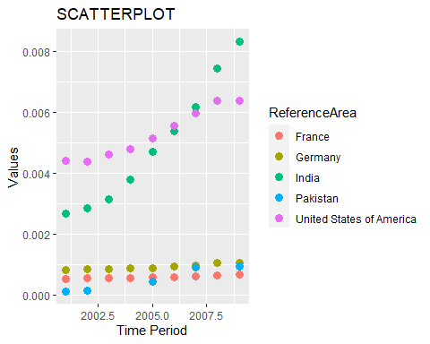

cor(train$TimePeriod, train$Scale)
## [1] 0.2751963
Indi <- cor(a1$TimePeriod, a1$Scale)
Frn <- cor(a2$TimePeriod, a2$Scale)
Usa <- cor(a5$TimePeriod, a5$Scale)
Ger <- cor(a3$TimePeriod, a3$Scale)
Pak <- cor(a4$TimePeriod, a4$Scale)
fdata <- data.frame(C_name = rep(c('India', 'France', 'Germany', 'Pakistan', 'USA')),
Cor_Val = rep(c(Indi, Frn, Ger, Pak, Usa)))
fdata
## C_name Cor_Val
## 1 India 0.9465078
## 2 France 0.9958850
## 3 Germany 0.9845807
## 4 Pakistan 0.9594195
## 5 USA 0.9931212

Conclusion: Scatterplot showing the correlation between Time Period and Observation Values for each selected countries. Also, a table showing the correlation values for each countries.

Regression:

Statement : Apply regression to predict the future value of one/more variables if applicable. (If not applicable, justify):

Code:

l1 <- lm(Scale~TimePeriod, a1)
summary(l1)
##
## Call:
## lm(formula = Scale ~ TimePeriod, data = a1)
##
## Residuals:
## Min 1Q Median 3Q Max
## -1.255e-03 -8.884e-04 -3.359e-05 6.942e-04 2.086e-03
##
## Coefficients:
## Estimate Std. Error t value Pr(>|t|)
## (Intercept) -1.223e+00 1.118e-01 -10.93 3.06e-08 ***
## TimePeriod 6.127e-04 5.583e-05 10.97 2.92e-08 ***
## ---
## Signif. codes: 0 '***' 0.001 '**' 0.01 '*' 0.05 '.' 0.1 ' ' 1
##
## Residual standard error: 0.001029 on 14 degrees of freedom
## Multiple R-squared: 0.8959, Adjusted R-squared: 0.8884
## F-statistic: 120.5 on 1 and 14 DF, p-value: 2.916e-08
#Predicted Values
prd <- predict(l1)
prd
## 1 2 3 4 5 6
## 0.0025684612 0.0031811719 0.0037938827 0.0044065935 0.0050193042 0.0056320150
## 7 8 9 10 11 12
## 0.0062447257 0.0068574365 0.0074701472 0.0080828580 0.0086955688 0.0093082795
## 13 14 15 16
## 0.0001176182 0.0007303289 0.0013430397 0.0019557504
#Error Values
er <- a1$Scale - prd
er
## 1 2 3 4 5
## -2.684977e-05 -5.078619e-04 -9.558241e-04 -1.255017e-03 -1.235272e-03
## 6 7 8 9 10
## -9.355454e-04 -8.726668e-04 -6.695838e-04 -4.032260e-05 2.394116e-04
## 11 12 13 14 15
## 1.040727e-03 2.085993e-03 1.280937e-03 9.346030e-04 6.140168e-04
## 16
## 3.032557e-04
ggplot(a1, aes(TimePeriod, Scale))+geom_point()+geom_smooth(method = "lm", formula = y~x, col="red", se=F)

Plot:

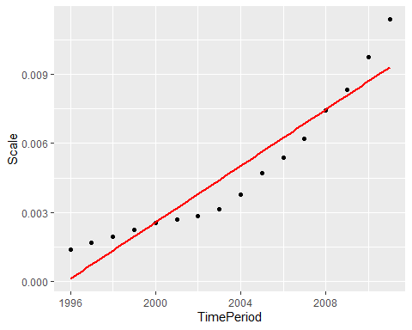

Conclusion: As regression we have taken the Country India and predicted values for it and checked the values matches with the actual values and with error values, we have confirmed that the normalized values and predicted values are nearly same. Also plotted the scatterplot for India showing the regression line.

Classification:

Statement: Apply a suitable classifier to classify the given data into one/two classes if applicable. (If not applicable, justify).

Conclusion: In the given dataset we cannot perform the classification techniques as there is not any categorical variable from which can classify the class of any object of sample dataset.

